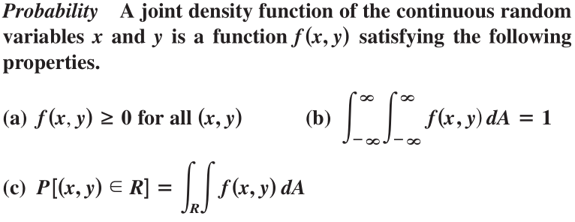

Exercises:

1. Show that the given function is a joint density function and find the given probability.

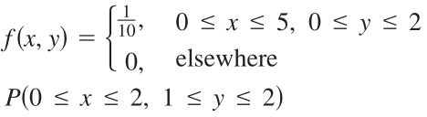

1. Show that the given function is a joint density function and find the given probability.

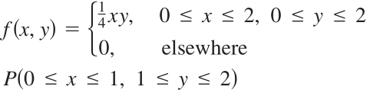

1. Find *k* such that the function

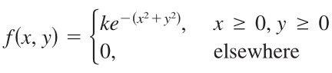

is a probability density function.

Suppose X is a random variable with probability density function *f1(x)* and Y is a random variable with density function *f2(y)*. Then X and Y are called *independent* *random variables* if their joint density function is the product of their individual density functions:

*f(x,y) = f1(x) f2(y)*

Exercises:

1. The manager of a movie theater determines that the average time movie-goers wait in line to buy a ticket for this week's film is 10 minutes and the average time they wait to buy popcorn is 5 minutes. Assuming the waiting times are independent, find the probability that a moviegoer waits a total of less than 20 minutes before taking his or her seat.

Remark: A model that can be used to model waiting times is an exponential density function, namely: $f\left(t\right)= \left\{\begin{aligned}0 if t<0 \\ μ^{-1}e^{-\frac{t}{μ}} if t≥0\end{aligned}\right.$ where $μ$ is the mean waiting time.

2. A factory produce (cylindrically shaped) roller bearings that are sold as having diameter 4.0 cm and length 6.0 cm. In fact, the diameters X are normally distributed with mean 4.0 cm and standard deviation 0.01 cm while the lengths Y are normally distributed with mean 6.0 cm and standard deviation 0.01 cm. Assuming that X and Y are independent, write the joint density function and graph it. Find the probability that a bearing chosen randomly from the production line has either length or diameter that differs from the mean by more than 0.02 cm. (In other words, compute P(3.98 < X < 4.02, 5.98 < Y < 6.02))

Remark: This problem involves making use of so-called *normal distributions* for the probability density functions. A single random variable is *normally distributed* if its probability density function has the form:

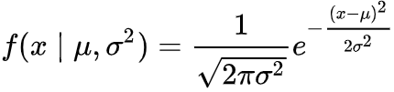

Where:

µ is the mean or expectation of the distribution (and also its median and mode),

σ is the standard deviation, and

σ2 is the variance.